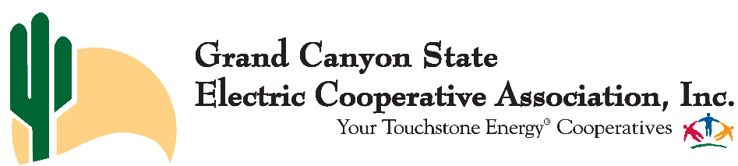

Summer Meeting of Members Agenda
July 19-22, 2021
Little America Hotel
2515 E. Butler Ave. | Flagstaff, AZ 86004

Monday, July 19

12:00 – 4:00 p.m. Board Presidents Lunch and Meeting

Tuesday, July 20

6:30 a.m. – 1:00 p.m. 21st Annual Miles Oldfather Golf Classic
Continental Golf Course
2380 N. Oakmont Dr., Flagstaff, AZ 86004

6:30 a.m. Golf Registration

7:30 a.m. Tee off

1:00 p.m. – 4:00 p.m. Meeting Registration

2:30 p.m. – 5:00 p.m. GCSECA Board of Directors Meeting (open to membership)

5:30 p.m. – 7:00 p.m. Reception Sponsored by Federated Rural Electric Insurance Exchange
Presentation of GCSECA Awards

Wednesday, July 21

7:30 a.m. – 11:00 a.m. Registration

8:00 a.m. - 11:40 a.m. General Session

- 8:00 Welcome, Jeff Larson
- 8:05 Co-op champion award
- 8:15 Keynote Speaker – “U.S. Electric Power Sector: Trends and Emerging in Context.” – David Gattie, University of Georgia

- 9:15 Reports from our Business Partners
  - CFC
  - NRTC
  - CoBank
  - Federated
- 10:15 Break
- 10:30 Federal Update – NRECA
- 11:15 Emerging Communication Trends – Pioneer Utility Services
- 12:00 General Session Ends

12:00 – 2:00 p.m. General Membership Luncheon
AzACRE Membership Meeting & Auction
Speaker: Sen. Sine Kerr, Chair, Arizona Senate Natural Resources, Energy and Water Committee

2:30 p.m. – 3:45 p.m. Water Policy Panel

3:45 p.m. – 4:00 p.m. Break

4:00 p.m. – 4:30 p.m. Members-only Roundtable

Thursday, July 22

8:00 a.m. – 4:30 p.m. NRECA BLC Directors Course
955.1 Your Board’s Culture: It’s Impact on Effectiveness

9:00 a.m. – 2:00 p.m. Group Purchasing Committee Meeting

*Dress for all meetings is business casual.*

